


\

Special Educational Needs & Disability (SEND) Mediation:

A Guide for Young People
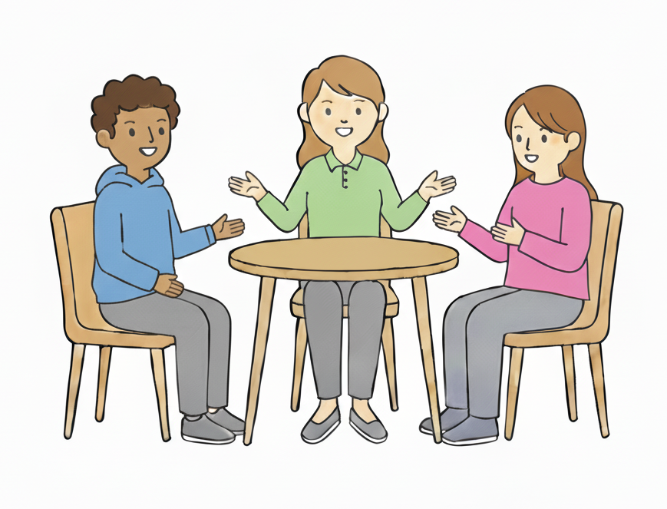


Watch a video guide here:
https://civilmediation.org/send-guide-for-young-people/
Mediation | A way of trying to sort things out when people don’t agree.
Mediator | A person who runs mediation and helps people sort things out.
Local authority | This is the council in charge of running things in your area.
EHC Plan | An education, health and care plan. Lots of young people with special educational needs get the right help without an EHC Plan, but some young people will need one. It says what support they must get.
EHC Needs Assessment | An education, health and care needs assessment. This will look at what extra support someone with special educational needs might need.
SENDIASS | SEND Information Advice and Support Service. They can help you with information.
Tribunal | Where a person called a judge listens to you or your parent carer, and the local authority. They then use the law to make a decision.
Judge | A person in charge of a tribunal. They hear everyone’s views then decide what is best.
Appeal | Asking a tribunal to look at the decision when you’re not happy.
Certificate | A form the mediator gives you or your parent carer. You need this to appeal. You get this after mediation, or if you tell the mediator you don’t want mediation.
Mediation service | They can give you information about mediation. They can also set up mediation if you ask for it. Mediators work for them.
Local Offer | Every council has a ‘Local Offer’ website. This is information about what support young people with special educational needs can get in their area.
Some words you might not know
What is SEND Mediation?




You can ask for mediation if you are unhappy with what the local authority has decided about your EHC Plan. Or if they don’t give you an EHC Plan or an EHC Needs Assessment.
A mediator helps people share their views and try to agree on something that works.
Mediation is to try and sort things out when people don’t agree.
It helps solve problems in a way that is calm, and as quick as possible.
This can be a meeting, but it may be different for you.

Who is the mediator?

A mediator helps everyone work together to sort things out.

They manage the mediation.

They help everyone stay calm and polite.

They make sure it is fair and everyone has their say.

They do not make decisions or tell anyone what to decide.

They do not work for the local authority.

They are trained in Special Educational Needs and Disabilities.











What happens at mediation?

- You or your parent carer have a meeting with the mediator and a person from the local authority.

- Your school or college might be at the meeting. You can bring a supporter, too.

- The meeting will probably be online, but may be in person.

- Everyone at the meeting shares what they think and listens to everyone else.

- Everyone talks about the help you need and what matters to you.










What happens at mediation?

- The mediator helps everyone listen to each other and try to sort out the problem.

- Everyone works together and tries to agree something that works for you.

- The meeting is often about 2 hours long (but could be longer or shorter).

- You can have a break at any time.

- No-one is allowed to tell anyone else what you have talked about in the meeting, unless you say they can. They can only share it if they are worried about the safety of you or others.











Should I be at the meeting?

You can be at the meeting if you want.
This could be:
- with a parent carer
- on your own if you are over 16
- with someone else you choose to support you
You can stay for as long as you like.





You don’t have to be at the meeting if you don’t want.

It is still good for everyone to know what you think, so here are some ways that you could be involved:

- fill in a form about you and the support you think will help.

- write an email or letter to the mediator.

- speak to the mediator or someone you trust before the meeting. They can share your views in the mediation.

- make a video or sound recording.

- draw your thoughts, feelings or worries.

Top tips
Think about who should come to the meeting and tell the mediator. It often really helps if someone from school or college comes along.


You can ask anyone to come to support you or share useful information.





Tell the mediator what will help you feel comfortable (for example, having cameras off, or meeting face to face).


The mediator will help you get ready for the meeting and make sure you feel comfortable.

If you are over 16, you can make your own decisions at mediation. Your parent carer does not have to make decisions for you, but they can if you want them to.


Getting help with mediation
Your parent carer or someone else you know can help you. If you like, they can speak to the mediator
for you.

You can take people to your mediation meeting to support you. They can help you say what you want to say. This could be a parent carer, friend, or anyone you trust.

You can speak to the SEND Information, Advice and Support Service (sometimes called SENDIASS or IASS) for your area.

They can give free advice about mediation and appeals. You can find their details on your local authority’s Local Offer website and the local authority decision letter.

SENDIASS may attend mediation with you.



If mediation does not sort out the problem


After mediation, the mediator will give you or your parent carer a certificate.

You will then have 1 month to appeal to the tribunal, or 2 months from the date on the local authority decision letter, whichever is later.

You need a certificate to appeal, unless you just want to appeal about where you go to school or college (then you don’t need one).

A tribunal is where you or your parent carer ask a judge if they can change the local authority’s decision. A judge hears everyone’s views then decides what is best.

You will need to fill in a form. To appeal, go to the tribunal service website:
www.gov.uk/courts-tribunals/first-tier-tribunal-special-educational-needs-and-disability

You don’t have to try mediation to appeal, but you still need to contact a mediation service first. They will give you information about mediation. If you tell them you don’t want mediation, they will give you a certificate so you can appeal straight away.



Flowchart
The local authority sends you a decision letter. This will tell you how to contact a mediation service. You have 2 months to contact the mediation service.



The mediation service gives you information about mediation.

You ask for mediation.
You tell the mediation service you don’t want mediation.



The mediation service gives you a certificate.
You have mediation. This is set up by the mediation service.
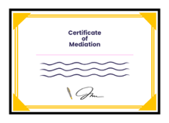

You then have 1 month to appeal, or 2 months from the date on the decision letter, whichever is later.
After mediation, the mediation service gives you a certificate.
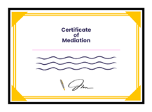

The problem has been sorted out by mediation.
The problem has not been sorted out. You have 1 month to appeal, or 2 months from the date on the decision letter, whichever is later.


The College of Mediators and Civil Mediation Council SEND Panel would like to thank everyone who helped in making this guide, including:

- Chapel Mediation Service
- Collis Mediation Ltd
- Global Mediation
- Kids & Kids SEND Mediation Service
- Prime Resolution
- Together Trust
- The Participation Collective
- FLARE

and all the young people who contributed.

